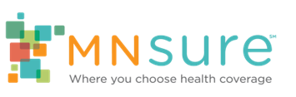

# Open Enrollment Social Media Toolkit

MNsure Key Dates
Nov. 1: Open enrollment starts
Dec. 18: Deadline for coverage starting Jan. 1
Jan. 15: Deadline for coverage starting Feb. 1
7 posts to share during open enrollment

## Suggested Post Copy & Visuals

*You can copy and paste the text. High-resolution image files are available for download on Assister Central under* [*Press and Social Media*](https://www.mnsure.org/assister-central/shared-resources/outreach/press-sm/index.jsp)*.*

### Open enrollment kickoff

It’s time to get covered, Minnesota! @MNsure open enrollment for health insurance begins today. Sign up by December 18 to get the peace of mind that comes with a full year of coverage in 2025.

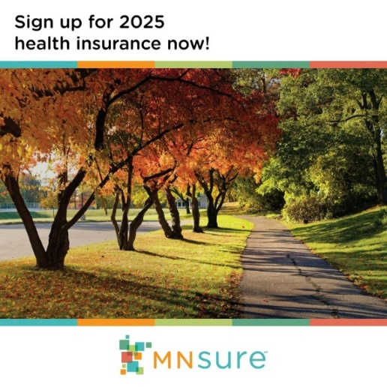

**Alt Text:** Tree-lined Minnesota street in autumn. Text encourages Minnesotans to sign up for 2025 health insurance.

### Savings available through MNsure

Don’t miss out on savings available through @MNsure! We can help you apply for health insurance, see if you qualify for free- or low-cost options & find the right coverage for you. Contact us today for free help: [WEBSITE/PHONE]

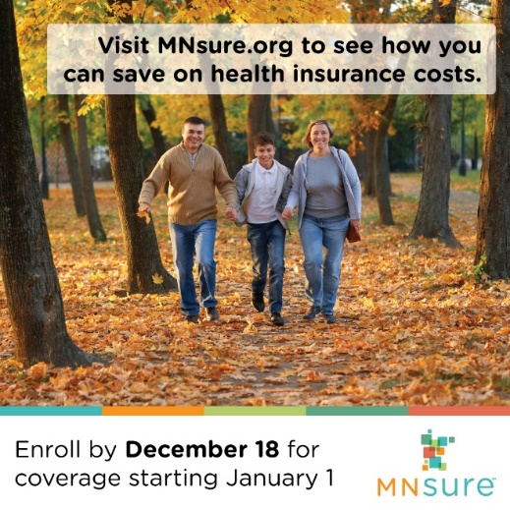

**Alt Text:** Family of three walking in a park in autumn. A text box says visit MNsure.org to see how you can save on health insurance costs and enroll by Dec. 18 for coverage starting Jan. 1.

### Free expert help

Confused by health insurance? We’re here to guide you through the whole @MNsure process, from start to finish. Schedule your free help session today [WEBSITE/PHONE]. Dec. 18 is the last day to enroll for health insurance that starts Jan. 1!

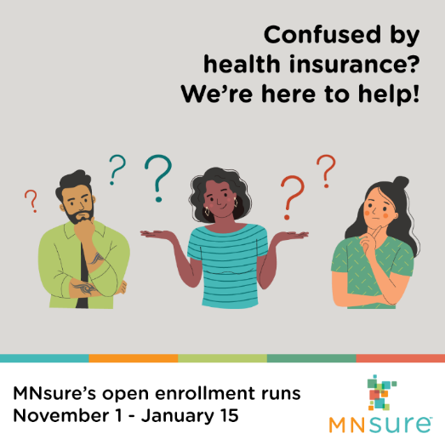

**Alt Text:** Three people surrounded by question marks. Text above them says, "Confused by health insurance? We're here to help!"

### (A) Get help from brokers

Need help deciding which health insurance plan is best for your family? That’s where we come in. We can give personalized, free advice & help you sign up through @MNsure. Contact us to schedule a free help session. [WEBSITE/PHONE]

OR

Let’s find the health insurance plan that’s right for you. We can help with your @MNsure application so you can be sure your family is covered. Contact us to schedule a free help session. [LINK/PHONE]



**Alt Text:** Client meeting with a broker with a banner encouraging MNsure consumers to schedule a free help session with a broker.

### (B) Get help from navigators

Health insurance provides care for you and your family to stay healthy and prevent illness. We’re here to help you apply through @MNsure, see if you qualify for free- or low-cost options & find the right coverage for you. Meet with us today! [LINK/PHONE]

OR

Health insurance protects you and your family from a lifetime of financial burden if an accident or illness happens. We can help with your @MNsure application so you can be sure your family is covered. Contact us at [LINK/PHONE]

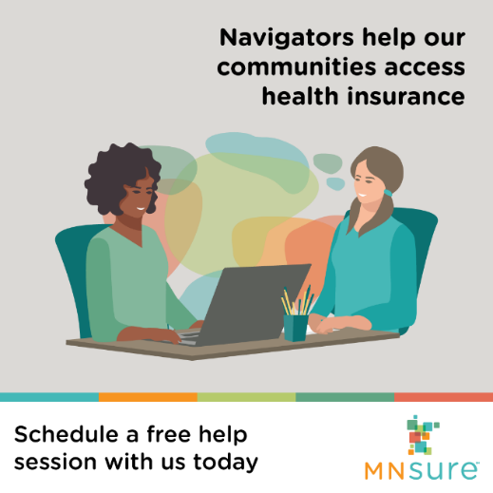

**Alt Text:** A young woman meeting with a navigator below a text box saying, “Navigators help our communities access health insurance.”

### December 18 deadline reminder

December 18 is the last day to sign up through @MNsure for private health insurance that starts Jan. 1, 2025! If you need help getting covered, give us a call today [WEBSITE/PHONE]

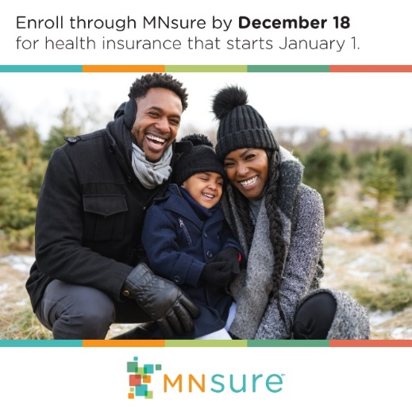

**Alt Text:** Parents and their young child smiling outdoors in early winter below a text box that says enroll through MNsure by December 18 for health insurance that starts January 1.

### You can still get covered for 2025

t’s not too late — you can still get covered! @MNsure open enrollment for private health plans runs through Jan. 15, 2025. We can help you apply for health insurance, see if you qualify for free- or low-cost options & find the right coverage for you. We’re here to help: [WEBSITE/PHONE]



**Alt Text:** Smiling couple outside in a park in the winter. Banner at the bottom reminds viewers that MNsure’s open enrollment goes until January 15, 2025.

### January 15 deadline reminder

Get quality, comprehensive health insurance for 2025 that covers doctor visits, prescription drugs and more.! January 15 is the last day to sign up through @MNsure for private health plans that start on February 1. We’re here to help: [WEBSITE/PHONE]



**Alt Text:** A smiling young woman walking downtown in the evening with a text reminder reminding Minnesotans to sign up through MNsure by January 15 for 2025 health insurance.

## Background

MNsure is Minnesota’s official health insurance marketplace. We connect Minnesotans who need health insurance with quality, comprehensive coverage and access to discounts (tax credits) that lower health insurance costs.

Open enrollment is the annual opportunity when Minnesotans across the state can compare health insurance options, sign up for coverage, or change plans through MNsure — without needing a qualifying life event. This year, MNsure’s open enrollment period runs November 1, 2024 – January 15, 2025.